1. **List out features of AngularJS.**
   * Data-binding
   * Scope
   * Controller
   * Services
   * Filters
   * Directives
   * Templates
   * Routing
   * Model View Whatever
   * Deep Linking
   * Dependency Injection
2. **Advantages of AngularJS**

* AngularJS provides capability to create Single Page Application in a very clean and maintainable way
* AngularJS provides data binding capability to HTML. Thus, it gives user a rich and responsive experience
* AngularJS code is unit testable
* AngularJS uses dependency injection and make use of separation of concerns
* AngularJS provides reusable components.
* With AngularJS, the developers can achieve more functionality with short code.
* In AngularJS, views are pure html pages, and controllers written in JavaScript do the business processing.

1. **Explain MVC Architecture of AngularJS. ,**

**5) Explain architecture of AngularJS with diagram.**

**M**odel **V**iew **C**ontroller or MVC as it is popularly called, is a software design pattern for developing web applications. A Model View Controller pattern is made up of the following three parts

* **Model** − It is the lowest level of the pattern responsible for maintaining data.
* **View** − It is responsible for displaying all or a portion of the data to the user.
* **Controller** − It is a software Code that controls the interactions between the Model and View.
* MVC is popular because it isolates the application logic from the user interface layer and supports separation of concerns. The controller receives all requests for the application and then works with the model to prepare any data needed by the view. The view then uses the data prepared by the controller to generate a final presentable response. The MVC abstraction can be graphically represented as follows.

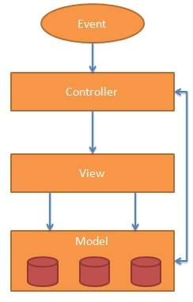

**The Model**

The model is responsible for managing application data. It responds to the request from view and to the instructions from controller to update itself.

**The View**

A presentation of data in a particular format, triggered by the controller's decision to present the data. They are script-based template systems such as JSP, ASP, PHP and very easy to integrate with AJAX technology.

**The Controller**

The controller responds to user input and performs interactions on the data model objects. The controller receives input, validates it, and then performs business operations that modify the state of the data model.

AngularJS is a MVC based framework. In the coming chapters, we will see how AngularJS uses MVC methodology.

1. **List out all filters of AngularJS. Explain with example.**

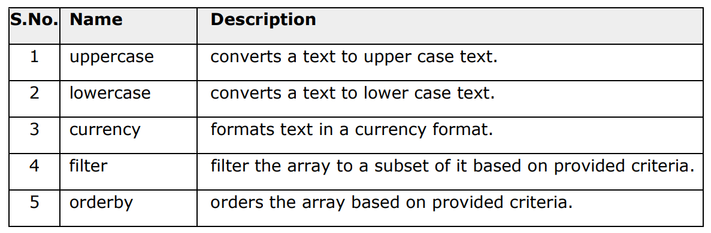

<!DOCTYPE html>

<html>

<script src="https://ajax.googleapis.com/ajax/libs/angularjs/1.6.9/angular.min.js"></script>

<body>

<div ng-app="myApp" ng-controller="personCtrl">

<p>The name is {{ lastName | uppercase }}</p>

</div>

<script>

angular.module('myApp', []).controller('personCtrl', function($scope) {

    $scope.firstName = "John",

    $scope.lastName = "Doe"

});

</script>

</body>

</html**>**

6) **Difference between AngularJS and Angular. And features of AngularJS.**

* **Angular** and **AngularJS** are two popular frameworks used for building dynamic web applications. While both are developed by Google, they are fundamentally different in terms of architecture, features, and performance.
* [AngularJS](https://www.geeksforgeeks.org/angularjs/), released in 2010, is the older, [JavaScript](https://www.geeksforgeeks.org/javascript/)-based version, while[Angular](https://www.geeksforgeeks.org/angular-tutorial/), introduced in 2016, is a complete rewrite using [TypeScript](https://www.geeksforgeeks.org/typescript/). In this article, we will learn the differences between AngularJS and Angular.

## AngularJS

* AngularJS is an open-source front-end framework based on JavaScript that is mainly used to develop single-page web applications(SPAs). It is a continuously growing and expanding framework which provides better ways for developing web applications. It changes the static [HTML](https://www.geeksforgeeks.org/html-tutorial/) to dynamic HTML. Its features like [dynamic binding](https://www.geeksforgeeks.org/angularjs-data-binding/) and [dependency injection](https://www.geeksforgeeks.org/angular-dependency-injection/) eliminate the need for code that we have to write otherwise.
* AngularJS is rapidly growing and because of this reason, we have different versions of AngularJS with the final version being 1.8.3. It is also important to note that Angular is different from AngularJS. It is an open-source project which can be freely used and changed by anyone. It extends HTML attributes with Directives, and data is bound with HTML.

### **Features of AngularJS**

* **MVC Architecture**: Separates the application into three interconnected components, making the code more organized and manageable.
* **Two-Way Data Binding**: Automatically synchronizes data between the model and the view, reducing the amount of boilerplate code.
* **Directives**: Custom HTML tags that enhance the functionality of elements and help create reusable components.
* **Dependency Injection**: Manages dependencies of various components, improving code modularity and testing.
* **Routing**: Built-in support for routing allows developers to create single-page applications with multiple views.

7) **Explain main directives of AngularJS with example. ng-app, ng-controller, ng-bind.**

## ng-app directive

ng-app directive defines the root element. It starts an AngularJS Application and automatically initializes or bootstraps the application when web page containing AngularJS Application is loaded. It is also used to load various AngularJS modules in AngularJS Application.

1. <div ng-app = ""**>**
2. ...
3. **</**div**>**

9) **Explain event driven directives of AngularJS. (ng-click, dbl-click, mouse-down, mouse- over, keydown).**

**ng-click** **Directive**

Add ng-click attribute to an HTML button and update a model. Bind the model to HTML and see the variation.

<body ng-app="">

<p>Click the button:</p>

<button ng-click="count = count + 1" ng-init="count=0">OK</button>

<p>The button has been clicked {{count}} times.</p>

</body>

**mouse-down :**

<body ng-app="">

<div ng-mousedown="count = count + 1" ng-init="count=0">Click me!</div>

<h1>{{count}}</h1>

</body>

**10)** What is AngularJS Modules? List out types of Modules.

The **AngularJS module** defines the functionality of the application which is applied on the entire HTML page. It helps to link many components. So it is just a group of related components. It is a container that consists of different parts like controllers, services, and directives.

controllers, services, and directives

**11) What is AngularJS?**

AngularJS is a **JavaScript framework**. It can be added to an HTML page with a <script> tag.

AngularJS extends HTML attributes with **Directives**, and binds data to HTML with **Expressions**.